9 Tools, 9 Habits

Jennifer Engel
Copyright © 2021

Copyright © 2020 Jennifer Engel
All rights reserved.

Published by Amazon Kindle Direct 2020

No parts of this publication may be reproduced, stored in a retrieval system, or transmitted in any form or by any means, electronic, mechanical, photocopying, recording, or otherwise, without the prior written permission of the copyright owner. For permission requests, write to the author, addressed, “Attention: Permission Request,” using the information below:

Jennifer Engel
11 East Main Street
Saint Charles, IL 60174
jenniferengel@blessedbasedbusiness.com

This book is sold subject to the condition that it shall not, by way of trade or otherwise, be lent, resold, hired out, or otherwise circulated without the publisher’s prior consent in any form of binding or cover other than that in which it is published and without a similar condition including this condition being imposed on the subsequent purchaser. Under no circumstances may any part of this book be photocopied for resale.

ISBN:

Ordering Information: www.highestpossibilitystates.com

Edited by Charles Reibly

Highest Possibility States and Inspire and Illuminate LLC

Disclaimer
If you require any more information or have any questions about our book's disclaimer, please feel free to contact us by email at highestpossibilitystates@gmail.com.

All the information in this book is published in good faith and for general information only. Highest Possibility States does not make any warranties about the completeness, reliability, and accuracy of this information. Any action you take upon the information you find in this book is strictly at your own risk. Highest Possibility States will not be liable for any losses in connection with the use of the information found within this book.

All content including: text, images, or other formats were created for informational purposes only. The Content is not intended to be a substitute for professional medical advice, diagnosis, or treatment. Always seek the advice of your physician or other qualified health providers with any questions you may have regarding a medical condition. Never disregard professional medical advice, or delay in seeking it because of something you have read in this book.

If you think you may have a medical emergency, call your doctor, go to the emergency room, or call 911 immediately. Highest Possibility States and Inspire and Illuminate LLC does not recommend or endorse any specific tests, physicians, products, procedures, opinions, or other information that may be mentioned by Highest Possibility States and/or Inspire and Illuminate LLC. Reliance on any information provided by Highest Possibility States, and Inspire and Illuminate LLC, and it’s contractors is solely at your own risk.

Consent
By reading this book you hereby consent to our disclaimer and agree to its terms
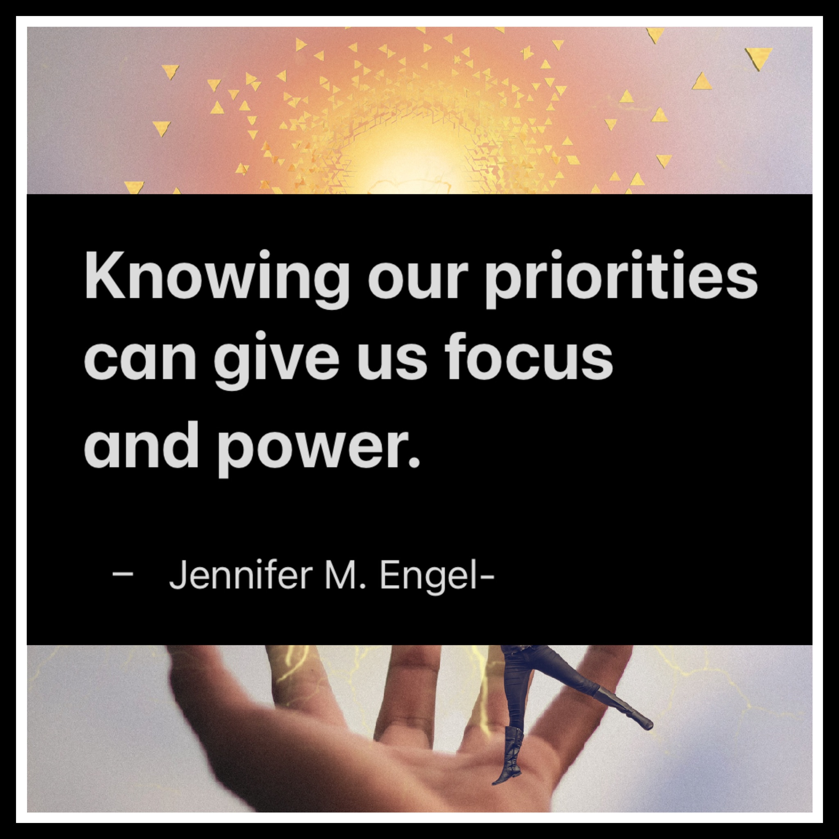

From Tool & Habit 1: Knowing Your Priorities

Use the chart below to determine where your current focus is as well as where you wish it would be.

Number... | What do you believe your top 3-5 priorities are in life? | Where do you spend your time the most? | What kind of things do you like to watch and read about on social media? | What images and things do you save to your phone or on your other electrical devices?
1.

2.

3.

4

5.

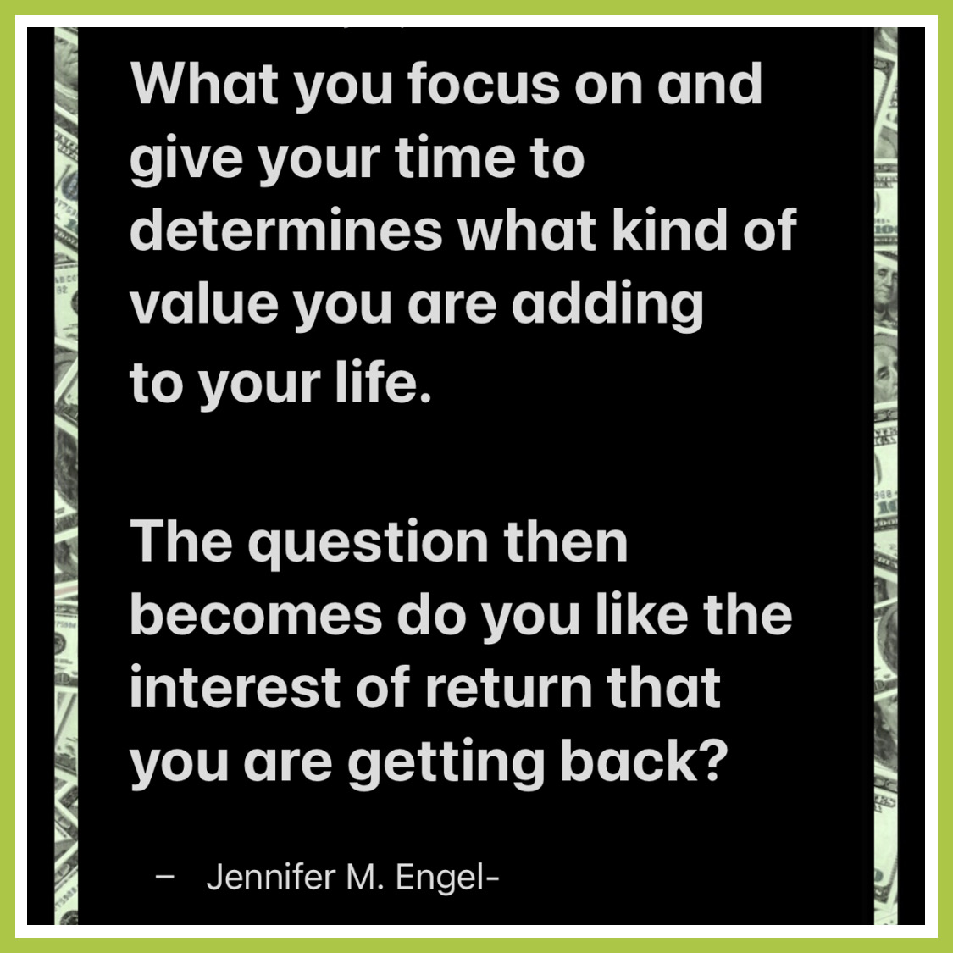
Self Assessment questions:

- Do the things you say are important to you reflect where you spend most of your time as well as what you focus on when it comes to social media?

- Do the things you focus on (and give your time and energy to) add value and a good return on your investment?

If so, awesome!

If you’d like more assistance processing ,
visit www.highestpossibilitystates.com for a free consultation as well as workshops coming this fall 2021!

Attribution-NonCommercial-NoDerivs - This license only allows others to download the work and share with others, as long as credit goes to the author. No changes can be made nor used commercially.

