9 Tools, 9 Habits

Jennifer Engel
Copyright © 2021

Copyright © 2020 Jennifer Engel
All rights reserved.

Published by Amazon Kindle Direct 2020

No parts of this publication may be reproduced, stored in a retrieval system, or transmitted in any form or by any means, electronic, mechanical, photocopying, recording, or otherwise, without the prior written permission of the copyright owner. For permission requests, write to the author, addressed, “Attention: Permission Request,” using the information below:

Jennifer Engel
11 East Main Street
Saint Charles, IL 60174
jenniferengel@blessedbasedbusiness.com

This book is sold subject to the condition that it shall not, by way of trade or otherwise, be lent, resold, hired out, or otherwise circulated without the publisher’s prior consent in any form of binding or cover other than that in which it is published and without a similar condition including this condition being imposed on the subsequent purchaser. Under no circumstances may any part of this book be photocopied for resale.

ISBN:

Ordering Information: www.highestpossibilitystates.com

Edited by Charles Reibly

Highest Possibility States and Inspire and Illuminate LLC

Disclaimer
If you require any more information or have any questions about our book's disclaimer, please feel free to contact us by email at highestpossibilitystates@gmail.com.

All the information in this book is published in good faith and for general information only. Highest Possibility States does not make any warranties about the completeness, reliability, and accuracy of this information. Any action you take upon the information you find in this book is strictly at your own risk. Highest Possibility States will not be liable for any losses in connection with the use of the information found within this book.

All content including: text, images, or other formats were created for informational purposes only. The Content is not intended to be a substitute for professional medical advice, diagnosis, or treatment. Always seek the advice of your physician or other qualified health providers with any questions you may have regarding a medical condition. Never disregard professional medical advice, or delay in seeking it because of something you have read in this book.

If you think you may have a medical emergency, call your doctor, go to the emergency room, or call 911 immediately. Highest Possibility States and Inspire and Illuminate LLC does not recommend or endorse any specific tests, physicians, products, procedures, opinions, or other information that may be mentioned by Highest Possibility States and/or Inspire and Illuminate LLC. Reliance on any information provided by Highest Possibility States, and Inspire and Illuminate LLC, and it’s contractors is solely at your own risk.

Consent
By reading this book you hereby consent to our disclaimer and agree to its terms.

(From Tool & Habit 1: Know Your Priorities - pages 31-33)

Thinking About What You Value

Directions:
- Look at the chart on the next page.
- Place stars next to the things you value. There are blank spaces to add a few of your own.
- Highlight your top 3-5 values. Note: The fewer things you highlight, the more attention, time, and energy you’ll have and be able to give those things.
Once you know what you value, the next time someone or something asks for your attention and time, you can ask yourself:
Does this opportunity or experience line up with what I value, and what I say is important to me? Or, in other words, does this opportunity or experience line up with my top 3-5? If it does, great! Keep taking advantage of those opportunities, and experiences. If it doesn’t, you can politely decline.
Disclaimer: I do understand that there are some times and experiences that we cannot decline because they may be required in order to support yourself and/or the people that are important to you.

List of Possible Values & Beliefs
Quiet | Reflective | Communicative
Serious | Balanced | Fun
Detailed | Realistic | Optimistic
Responsible | Consistent | Carefree
Dependable | Scheduled | Go-With-the-Flow
Focused | Multi-Tasking | Whole Picture/Person
Business | Family | Friends
Committed | Leadership | Neutering
Loyal | Steady | Considerate
Wealth | Insightful | Health
Drive | Determination | Endurance
Discerning | Tolerant | Trust
Science | Education | Faith
Time alone | Balanced Time | Time with Others
Real | Raw | Transparent
Alert | Resourceful | Relaxed
Decisive | Organized | Clean
Independence | Responsible | Teamwork

Thinking about others:
- Look at the chart below.
- In the left side column, think about the top 3-5 people (groups of people) that are the most important to you.
- Ask yourself: Do these people (groups) contribute to, or take away from my values?
- In the right-side column of the chart, think about the top 3-5 people you are around the most. Do they match the left-side column, why or why not?

Top people/ groups of people (family, friends, coworkers, community members) that are most important to me. | The top people/ groups of people (family, friends, coworkers, community members) I am around the most.

Now that we’ve really analyzed ourselves, and what we say is important to us, the next habit will be to learn some tools we can use to start the clean-up process from where we are to where we say we want to be.

(From Tool & Habit 2: The Clean Up - pages 42 & 43)

The Three Questions:
Consideration: Before access to the internet, we all lived in pretty closed-off places and spaces, with people who often looked like us, and had similar thoughts and beliefs. Now we are exposed to the whole world, which thinks and acts and responds in so many different ways. This can make it confusing for what is right for you. Whenever I am learning anything new, I ask myself these three questions:

Question One: How does this information physically make my body feel?
If it makes my body feel positive, I keep listening and consider taking it into my own thought and belief system. If it feels negative, I change the channel.

Question Two: Will this information make me (and those around me) more functional over time?
Some people can handle a glass of wine a day or a hit from a joint now and then, others cannot. Sometimes things that seem fun at the time, can have devastating effects as time goes on. That is why it is imperative not just to ask yourself how the new thought makes you feel at the time, but how it makes you feel and function over time.

This will require some reflection and data collection over the course of several days. Consider keeping a journal, or a note on your phone, or downloading an app that monitors your mood. The data you collect can help determine if these new thoughts and experiments are leading you to your Highest Possibility State or taking you lower.
Question Three: Is this new thought and behavior causing me to be seen the way I want to be seen?
On one hand, not caring what others think about us can liberate us from fear, guilt, anger, jealousy, lies, and more. On the other hand, if your new ideas, thoughts, and behaviors can cause the people around you to see in you a light that you do not wish to be seen in. If this is the case, you may wish to consider how your new thoughts or behaviors are (or are not) serving your Highest Possibility State. Many times, people will “hide” thoughts and behaviors because they know it is not serving their highest good. Another reason people “hide” thoughts and behaviors is fear of being judged and hurt by the people they love the most. It can be tricky determining what thoughts and emotions are serving your Highest Possibility States, and which ones are taking you lower. Some thoughts and behaviors serve our Highest Possibility State, but they may go against mainstream belief and other people’s comfort levels.

The same thing can be said for Lower Possibility States as well. The answer comes from how you answered your questions, as well as going back and reflecting upon the top things and people you say are important to you and why. A question to ask may be are the people in my life supporting and adding to my Highest Possibility State, or are they bringing me lower? If the answer is “bring me lower” we will address this topic as we get into the next chapter.

(From Tool & Habit 3, as well as the back of the book)

Appendix A

Health

Overview & Purpose:
By the end of this self assessment, you will be able to determine if your health is an area of significant (or of little) priority, when it comes to thinking about taking steps towards achieving your Highest Possibility States.

Directions:
- Read the questions in each section.
- Circle the number that most relates to you as it applies to the question asked.

After I eat my meals...
Breakfast or Meal/Snack 1
My thoughts sound (x) ...
angry disappointed neutral calm happy energetic

My body feels (y) ...
in pain bloated heavy okay good excellent

Lunch or Meal/Snack 2
My thoughts sound (x) ...
angry disappointed neutral calm happy energetic

My body feels (y) ...
in pain bloated heavy okay good excellent

After I eat dinner, or a meal, or a snack...
My thoughts sound (x) ...
angry disappointed neutral calm happy energetic

My body feels (y) ...
in pain bloated heavy okay good excellent

After I exercise...
My thoughts sound sound (x) ...
angry disappointed neutral calm happy energetic

My body feels feels (y) ...
in pain bloated heavy okay good excellent

When I think about my energy throughout the day...
Morning
My thoughts sound (x) ...
angry disappointed neutral calm happy energetic

My body feels (y) ...
in pain bloated heavy okay good excellent

Afternoon
My thoughts sound (x) ...
angry disappointed neutral calm happy energetic

My body feels (y) ...
in pain bloated heavy okay good excellent

Evening
My thoughts sound (x) ...
angry disappointed neutral calm happy energetic

My body feels (y) ...
in pain bloated heavy okay good excellent

I have been diagnosed with a/several medical condition(s) that make...
My thoughts sound (x) ...
angry disappointed neutral calm happy energetic

My body feels (y) ...
Other Descriptors:
-6 to -5 = I’m in constant chronic pain and/or I can’t function.
-4 to -3 = I have some pain and/or I am often tired.
-2 to -1 = Occasional pain and/or I often need breaks.
0 = Occasional Ache, but no real pain and/or I have no real feelings.
+1 to +2 = No aches or pains or I’m usually in an okay mood.
+3 to +4 = I’ve developed positive coping strategies so no real effect.
+5 to +6 = I’ve turned my diagnosis into a strength and use it to my advantage.

I take medication and/or supplements that make...
My thoughts sound (x) ...
angry disappointed neutral calm happy energetic

My body feels (y) ...
in pain bloated heavy okay good excellent

When I look in the mirror...
My thoughts sound (x) ...
angry disappointed neutral calm happy energetic

My body looks (y) ...
hideous ugly okay good beautiful

Assessment Complete

Directions: Now that you have finished the assessment, go back and…
- Add up all of your numbers for your Xs (My thoughts sound) and divide your sum by ten.
This will give you your overall X average: ____
- Add up all of your numbers for your Ys (My body feels) and divide your sum by ten. This will give you your overall Y average: ____
- Plot your average (X,Y coordinate) on the graph, and see what quadrant your score falls into. This will also give you an idea if this is an area of strength, or if you need to trade-in, overhaul, or time-out.

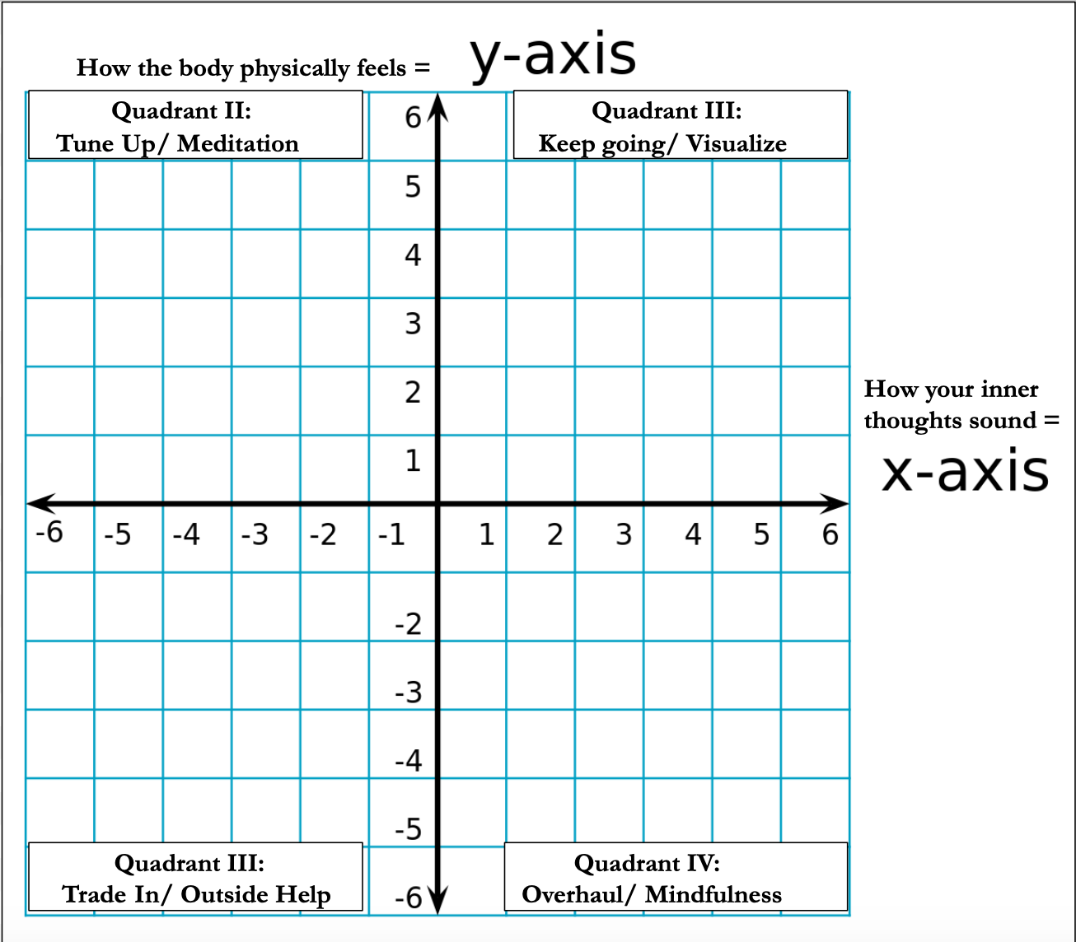

Now that you have assessed what quadrant you are in, you can go back to the corresponding section and review the tools and habits you can use to get to your desired destination.

Thinking Specifically about Quadrant III:
If you find that your graph places you into Quadrant III, this would be an area of major concern that should be addressed. If they are physical feelings and symptoms, please go to and work with your primary care physician. If you have been working with your primary care physician (or any other physician(s) and you still feel this way), consider changing doctors. If they are areas more related to food and overall body image, consider working with a nutritionist and/or personal trainer.

Remember:
This content is not intended to be a substitute for professional medical advice, diagnosis, or treatment. Always seek the advice of your physician or other qualified healthcare providers with any questions you may have regarding a medical condition. Never disregard professional medical advice or delay in seeking it because of something you have read in this book.

If you think you may have a medical emergency, call your doctor, go to the emergency room, or call 911 immediately.

Appendix B

Mental Health and Wealth

Overview & Purpose:
By the end of this self assessment you will be able to determine if your health is an area of significant (or of little) priority when it comes to thinking about taking steps towards achieving your Highest Possibility States.

Directions:
- Read the questions in each section.
- Circle the number that most relates to you as it applies to the question asked.

Money:
When I think about how steady my money flowing in is...
My thoughts sound (x) ...
angry disappointed neutral calm happy excited

My income is (y) …
none random monthly bimonthly weekly daily

When I think about my ability to pay bills and daily living expenses...
My thoughts sound (x) ...
angry disappointed neutral calm happy excited

My income is (y) …
none random monthly bimonthly weekly daily

When I think about an emergency that would cost hundreds or more…
My thoughts sound (x) ...
angry disappointed neutral calm happy excited

I would have to (y) …
borrow use credit cards use savings be able to pay

When it comes to savings…
My thoughts sound (x) ...
angry disappointed neutral calm happy excited

I have (y) …
never rarely inconsistently consistently diversify

When it comes to investments and/or multiple income streams...
My thoughts sound (x) ...
angry disappointed neutral calm happy excited

I have (y) …
none savings only 1-2 3-4 5-6 6+
Adventure:
When I think about my hobbies and passion(s)...
My thoughts sound (x) ...
angry disappointed neutral calm happy excited

I participate with others (y) …
never rarely inconsistently monthly weekly

When I think about getting out and trying new things...
My thoughts sound (x) ...
angry disappointed neutral calm happy excited

I get out (y) …
never rarely inconsistently monthly weekly

When Ithink about taking a trip somewhere in my state or country...
My thoughts sound (x) ...
angry disappointed neutral calm happy excited

I take trips (y) …
never 1-2 x per life 1-2 x per 5 years 1-2 x per year +

When Ithink about taking a trip outside of my country...
My thoughts sound (x) ...
angry disappointed neutral calm happy excited

I take trips (y) …
never 1-2 x per life 1-2 x per 5 years 1-2 x per year +

Feeling Functional:
When I think about being able to complete the tasks and chores at home…
My thoughts sound (x) ...
angry disappointed neutral calm happy excited

I complete them (y) …
never rarely inconsistently monthly weekly daily

When I think about being able to complete the tasks for the work I am paid for…
My thoughts sound (x) ...
angry disappointed neutral calm happy excited

I (y) …
-6 to -4 I’m barely able to keep up and often get fired. or the work environment makes me more stressed and feel sick.
-3 to 0 Like a Fraud. I use a lot of others to help me get by, or the work environment is toxic.
1-3 Okay. I can hold my own. I stay mostly to myself. It’s a pretty neutral palace to work.
4-6 Great. I am part of a team that works well together, even if management does or doesn’t always understand us. I may even feel empowered.

When I think about completing tasks I have in the community...
(volunteer, religious, clubs, or other organizations)
My thoughts sound (x) ...
angry disappointed neutral calm happy excited

I complete
them (y) …
never rarely inconsistently monthly weekly daily

Assessment Complete

Directions: Now that you have finished the assessment, go back and…
- Add up all of your numbers for your Xs (My thoughts sound) and divide your sum by twelve.
This will give you your overall average: ____
- Add up all of your numbers for your Ys (My body feels) and divide your sum by twelve. This will give you your overall average: ____
- Plot your average on the graph and see what quadrant your score falls into. This will also give you an idea if this is an area of strength, an area where you should take a timeout and reflect upon it. An area that needs a tune-up or a trade-in.

Now that you have assessed what quadrant you are in, you can go back to the corresponding section and review the tools and habits you can use to get to your desired destination.

Thinking Specifically about Quadrant III:
If you find that your graph places you into Quadrant III, this would be an area of major concern that should be addressed. If the low scores are more in the area of finance, consider working with a trusted financial advisor. If the low number areas are more in the area of feeling functional, consider working with a certified psychiatrist, psychologist, and/or counselor. It may not hurt to also consult your primary care physician to complete a physical. If you have been working with a financial advisor, a primary care physician, a certified psychiatrist, psychologist, and/or counselor, and you find you are still in Quadrant III, consider seeking and obtaining other opinions and/or trading in your current professional for a new one who can help you into a more positive state.

Remember:
This content is not intended to be a substitute for professional medical advice, diagnosis, or treatment. Always seek the advice of your physician or other qualified healthcare providers with any questions you may have regarding a medical condition. Never disregard professional medical advice or delay in seeking it because of something you have read in this book.

If you think you may have a medical emergency, call your doctor, go to the emergency room, or call 911 immediately.

Appendix C

Emotional-Relational Health

Overview & Purpose:
By the end of this self assessment you will be able to determine if your health is an area of significant (or of little) priority when it comes to thinking about taking steps towards achieving your Highest Possibility States.

Directions:
- Read the questions in each section.
- Circle the number that most relates to you as it applies to the question asked.

Relationship to Self:
When I think about my hygiene routine (showering, grooming, brush teeth, etc.) ...
My thoughts sound (x) ...
angry disappointed neutral calm happy excited

I groom (y) …
rarely monthly weekly several days a week daily +

On Average, when I step out into the community…
My thoughts sound (x) ...
angry disappointed neutral calm happy excited

I or other people (y) …
- People move away from me and don’t want to be near me, or I don’t want to be near anyone else.
- I don’t feel very well put together or as if I don’t fit in.
- I feel okay.
- I feel pretty well put together. I get some smiles and hellos.
- I am very put together. People just naturally come up and talk with me.

When I think about my daily habits…
My thoughts sound (x) ...
angry disappointed neutral calm happy excited

I feel (y) …
depressed bored numb satisfied content excited

When I think about setting long-term and/or short-term goals…
My thoughts sound (x) ...
angry disappointed neutral calm happy excited

I check on my goals (y) …
never rarely inconsistently monthly weekly daily

When I think about being alone with myself...
My thoughts sound (x) ...
angry disappointed neutral calm happy excited

I am alone (y) …
never rarely inconsistently monthly weekly daily

I think about being with the people I live with..
My thoughts sound (x) ...
angry disappointed neutral calm happy excited

I am around them (y) …
never rarely inconsistently monthly weekly daily

I think about being with my extended family..
My thoughts sound (x) ...
angry disappointed neutral calm happy excited

I am around them (y) …
never rarely inconsistently monthly weekly daily

I think about being with my coworkers..
My thoughts sound (x) ...
angry disappointed neutral calm happy excited

I am around them (y) …
never rarely inconsistently monthly weekly daily

WhenI think about how others perceive me...
My thoughts sound (x) ...
angry disappointed neutral calm happy excited

I think they like me (y) …
not at all a little half the Time most of the time

When I feel down or overwhelmed with life…
My thoughts sound (x) ...
angry disappointed neutral calm happy excited

I (y) …
Other Descriptors:
-6 to -5 = can’t function and/or may even be in pain
-4 to -3 = get tired or exhausted
-2 to -1 = often need breaks
0 = I have no real feelings
+1 to +2 = I’m usually in an okay mood.
+3 to +4 = I’ve developed positive coping strategies so no real effect.
+5 - +6 = I turn lemons into lemonade and use it to my advantage.

When I do feel down, and I think about my circle of support (people I can turn to)...
My thoughts sound (x) ...
angry disappointed neutral calm happy excited

I have ___ people to turn to (y) …
0 1-2 3-4 5-7 8-10 10+

When I think about having access to professional assistance...
My thoughts sound (x) ...
angry disappointed neutral calm happy excited

I have (y) …
-0 = I do not have access to anyone.
+1 = I have access to general physical (doctor) care
+2 = I have access to general physical (doctor) care, and a counselor.
+3 = I have access to general physical (doctor) care, a counselor, and one specialist.
+4 = I have access to general physical (doctor) care, a counselor, and two specialists.
+5 I have access to general physical (doctor) care, a counselor, and three or more specialists.
+6 I have access to any specialist I need at any time.

When I think about having access to counselors and/or spiritual advisors...
My thoughts sound (x) ...
angry disappointed neutral calm happy excited

I am around them (y) …
never rarely inconsistently monthly weekly daily

Assessment Complete

Directions: Now that you have finished the assessment, go back and…
- Add up all of your numbers for your Xs (My thoughts sound) and divide your sum by thirteen.
This will give you your overall average: ____
- Add up all of your numbers for your Ys (My body feels) and divide your sum by thirteen. This will give you your overall average: ____
- Plot your average on the graph and see what quadrant your score falls into. This will also give you an idea if this is an area of strength, an area where you should take a timeout and reflect upon it. An area that needs a tune-up or a trade-in.

Now that you have assessed what quadrant you are in, you can go back to the corresponding section and review the tools and habits you can use to get to your desired destination.

Thinking Specifically about Quadrant III:
If you find that your graph places you into Quadrant III, this would be an area of major concern that should be addressed. If the low number areas are in the area of relationships with self or others, consider working with a certified psychiatrist, psychologist, and/or counselor. It may not hurt to also consult your primary care physician to complete a physical. If you have been working with a primary care physician, a certified psychiatrist, psychologist, and/or counselor, and you find you are still in Quadrant III, consider seeking and obtaining other opinions and/or trading in your current professional for a new one who can help you into a more positive state.

If your scores were lowest in the area of adventure, consider planning a trip, joining a club, or organization of interest and/or working with a life coach.

Remember:
This content is not intended to be a substitute for professional medical advice, diagnosis, or treatment. Always seek the advice of your physician or other qualified healthcare providers with any questions you may have regarding a medical condition. Never disregard professional medical advice or delay in seeking it because of something you have read in this book.

If you think you may have a medical emergency, call your doctor, go to the emergency room, or call 911 immediately.

Appendix D

Identity and Purpose

Overview & Purpose:
By the end of this self assessment you will be able to determine if your health is an area of significant (or of little) priority when it comes to thinking about taking steps towards achieving your Highest Possibility States.

Directions:
- Read the questions in each section.
- Circle the number that most relates to you as it applies to the question asked.

Section A: How I See Myself
When I think about knowing myself…
My thoughts sound (x) ...
angry disappointed neutral calm happy excited

I think (y) …
not at all maybe kind of mostly absolutely

When I think about knowing my purpose in life...
My thoughts sound (x) ...angry disappointed neutral calm happy excited

I think (y) …
no clue maybe kind of mostly absolutely

Assessment Complete

This graphing part of the assessment is done:
- Add up all of your numbers for your Xs (My thoughts sound) and divide your sum by two.
This will give you your overall average: ____
- Add up all of your numbers for your Ys (My body feels) and divide your sum by two. This will give you your overall average: ____
- Plot your average on the graph and see what quadrant your score falls into. This will also give you an idea if this is an area of strength, an area where you should take a timeout and reflect upon it. An area that needs a tune-up or a trade-in.

Now that you have assessed what quadrant you are in, you can go back to the corresponding section and review the tools and habits you can use to get to your desired destination. If you find that your graph places you into Quadrant III, more inner reflection is needed. For that, move onto the next series of questions.

When people describe me, they often say that I am...
______________________________________________________________________________________________________________________________________________________________________________

When I describe myself I often say...
______________________________________________________________________________________________________________________________________________________________________________

What are you doing the most often in your photos that you post on social media?
______________________________________________________________________________________________________________________________________________________________________________

What do you most “like,” “love,” or comment about on other people’s social media pages?
______________________________________________________________________________________________________________________________________________________________________________

What do you find yourself searching for and watching the most on the internet, social media, or other entertainment outlets?
______________________________________________________________________________________________________________________________________________________________________________

What groups (if any) are you a part of in person or on social media?
______________________________________________________________________________________________________________________________________________________________________________

In the “about” section in social media what do you most share about?
(circle all that apply):
sports movies music apps and games
TV books other__________________________

I would do this one thing (or these multiple things) every day of my life, even if I was never paid to do them because I love doing it/them so much!
______________________________________________________________________________________________________________________________________________________________________________

The things that excite me most life are:
______________________________________________________________________________________________________________________________________________________________________________

Section B:
Note: This is a typical form that employers use to identify who their employees are.

The other information added to this typical form (sexual orientation) is also another societal identity indicator. The purpose for including this in the self assessment is to reflect on how you feel about how you identify yourself as you answer these questions.

Name: ______________________________________
Birthdate: _______________________ Age: _______
Date completed: _______________________________

GENDER:
(Please check one) _____ Male _____ Female

RACE/ETHNICITY: Please check one of the descriptions below corresponding to the ethnic group with which you identify.
___ Hispanic or Latino: A person of Cuban, Mexican, Puerto Rican, South or Central American, or other Spanish culture or origin regardless of race.
___ White (Not Hispanic or Latino): A person having origins in any of the original peoples of Europe, the Middle East or North Africa.
___ Black or African American (Not Hispanic or Latino): A person having origins in any of the black racial groups of Africa.
___ Native Hawaiian or Pacific Islander (Not Hispanic or Latino): A person having origins in any of the peoples of Hawaii, Guam, Samoa, or other Pacific Islands.
___ Asian (Not Hispanic or Latino): A person having origins in any of the original peoples of the Far East, Southeast Asia, or the Indian Subcontinent, including, for example, Cambodia, China, India, Japan, Korea, Malaysia, Pakistan, the Philippine Islands, Thailand, or Vietnam.
___ Native American or Alaska Native (Not Hispanic or Latino): A person having origins in any of the original peoples of North and South America (including Central America) and who maintains tribal affiliation, or community attachment.
___ Two or more races (Not Hispanic or Latino): All persons who identify with more than one of the above five races.
___ I do not wish to disclose.

RELIGIOUS BELIEF (pick one)
_____ Christian _____ Jewish _____ Buddhist _____ Hindu
_____ Earth Based _____ Muslim _____ Atheist
Other: ___________________________

POLITICAL AFFILIATION: (pick one)
______ Democrat _______ Republican ______ Independant
Other: ___________________________

HEALTH: (pick one)
_____ Able-bodied _____ Disabled
(describe): _________________________

Section C: Reflection on Section B

Were/Are you comfortable picking/choosing a gender?
Yes No
Explain: __________________________________________________________
__________________________________________________________

Where/Are you comfortable picking/choosing a race/ethnicity?
Yes No
Explain: __________________________________________________________
__________________________________________________________

Where/Are you comfortable picking/choosing a religious belief?
Yes No
Explain: ____________________________________________________________________________________________________________________

Where/Are you comfortable picking/choosing a political affiliation?
Yes No
Explain: __________________________________________________________
__________________________________________________________

Where/Are you comfortable commenting about your health?
Yes No
Explain: __________________________________________________________
__________________________________________________________

What does it feel like to be..
(complete all you can relate to or have thoughts about)
Your gender: _______________________________________________
I like playing the stereotype role. I like my gender, but not the stereotype.
Other thoughts: __________________________________________________________

Your family role (mother, father, son, daughter, aunt, uncle, etc.)
I like playing the stereotype role. I like my role, but not the stereotype.
Other thoughts: __________________________________________________________
__________________________________________________________

Your Cultural role. I identify my culture as_________________________
I like playing the stereotype role. I like my role, but not the stereotype.
Other thoughts: __________________________________________________________

Your religious, spiritual, or non-spiritual role. I identify myself as: _______
I like playing the stereotype role. I like my role, but not the stereotype.
Other thoughts: ____________________________________________________________________________________________________________________

Your political affiliation? I identify myself as: _____________________
I like playing the stereotype role. I like my role, but not the stereotype.
Other thoughts: ____________________________________________________________________________________________________________________

Physical Health? I identify myself as: able-bodied, or disabled
I like playing the stereotype role. I like my role, but not the stereotype.
I wish I was: ________________________________________________
Other thoughts: ____________________________________________________________________________________________________________________

Occupation or Community Role? I am a __________________________
I like playing the stereotype role. I like my role, but not the stereotype.
Other thoughts: __________________________________________________________
__________________________________________________________

What types of advantages (or disadvantages) come with how society identifies you versus how you identify yourself?
____________________________________________________________________________________________________________________________________________________________________________________________________________________________________________________________________________________________________________________________________________________________

What were some take-aways (or ah-ha moments) you had while reflecting upon this section and your answers?
____________________________________________________________________________________________________________________________________________________________________________________________________________________________________________________________________________________________________________________________________________________________

If you had to answer who you are and what are your passions, would you be able to do so? Why or why not?
____________________________________________________________________________________________________________________________________________________________________________________________________________________________________________________________________________________________________________________________________________________________

Think back to how you felt while answering these questions. Was there anything you wish you were instead? If you could describe your ideal self, how would you describe that person?
________________________________________________________________________________________________________________________________________________________________________________________________________________________________________

Final reflection:
Now that you have completed all of the self assessments, go back and determine what area you would like to focus on first.
Considerations for What to Focus on First:
Order of Importance | Quadrant | Area
1 | Items that scored in Quadrant III,  Self Destructive =  Trade In. | Physical Health
2 | Items that scored in Quadrant IV, Disgruntled = Overhaul. | Mental Health
3 | Items that scored in Quadrant II, Deconstruct in order to Reconstruct =  Tune Up. | Emotional/Relational Health
4 | Items that scored in Quadrant I, Self-Determined =  Reflect & Adjust  as needed. | Life Goal and Purpose

Now that you have a goal area in mind, go back to the beginning of this book and learn how to turn your goal into a clear picture, as well as learn how to overcome obstacles, so that it will be easier to commit towards achieving and arriving at your desired state.
Also keep in mind that this content is not intended to be a substitute for professional medical advice, diagnosis, or treatment. Always seek the advice of your physician, or other qualified health providers with any questions you may have regarding a medical condition. Work with them in conjunction to, and with, this book. Never disregard professional medical advice, or delay in seeking it, because of something you have read in this book
If you think you may have a medical emergency, call your doctor, go to the emergency room, or call 911 immediately.

Reviewing the Matrix
Turning it from a starting point
into a Map
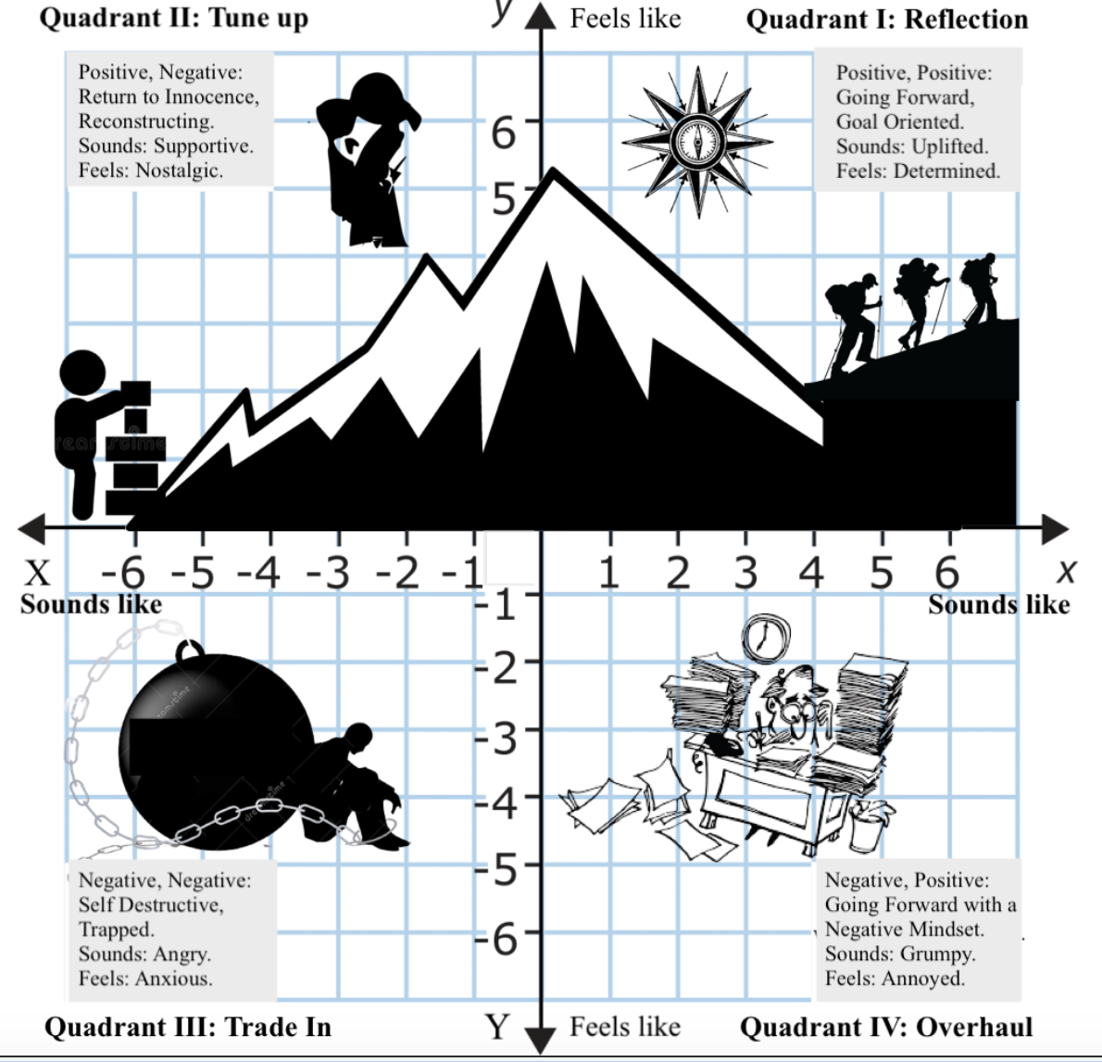

(From Tool & Habit 4: Willing to Work - page 51)

Setting Your Goal and Benchmarks

Self-Assessment: After deciding what area you want to work on over the next 3-6 months, ask yourself, “What small steps can I take to help that area feel just a little bit fresher and new, and how will I know if I am actually making progress”?

My goal is: _________________________________________________
___________________________________________________________

My benchmarks are: _________________________________________
__________________________________________________________

Attribution-NonCommercial-NoDerivs - This license only allows others to download the work and share with others, as long as credit goes to the author. No changes can be made nor used commercially.

